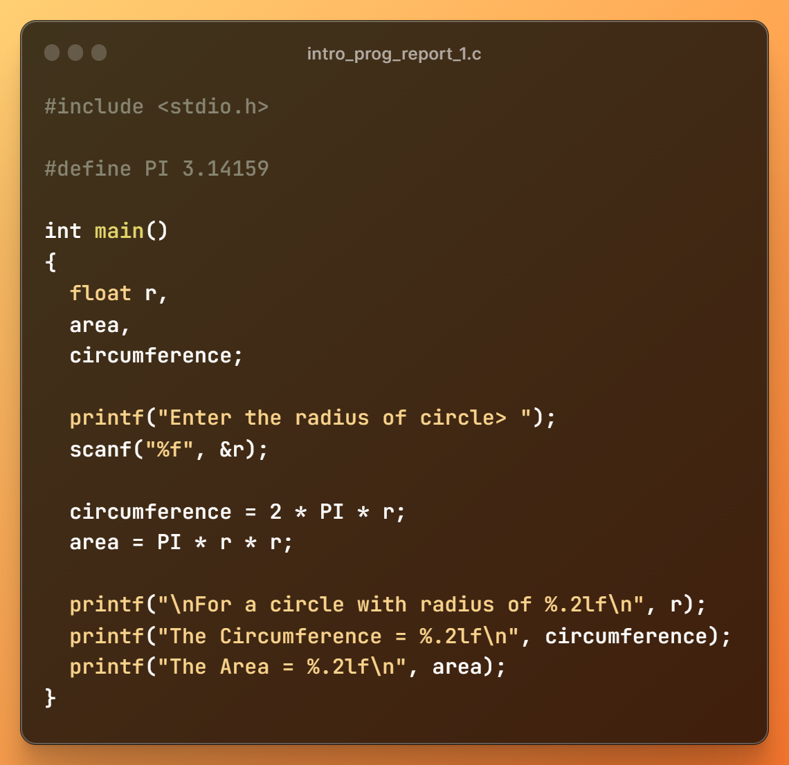Report 1

## Output:

Enter the radius of circle> 4.2 For a circle with radius of 4.20 The Circumference = 26.39 The Area = 55.42